fundamentl of computer programming

lab_06

October 25, 2024

HANAN MAJEED

CMS ID:519166

: **Task A:**

Get 10 even numbers from the user and show their sum. If the user enters an odd number, show an appropriate message as shown below

Input :

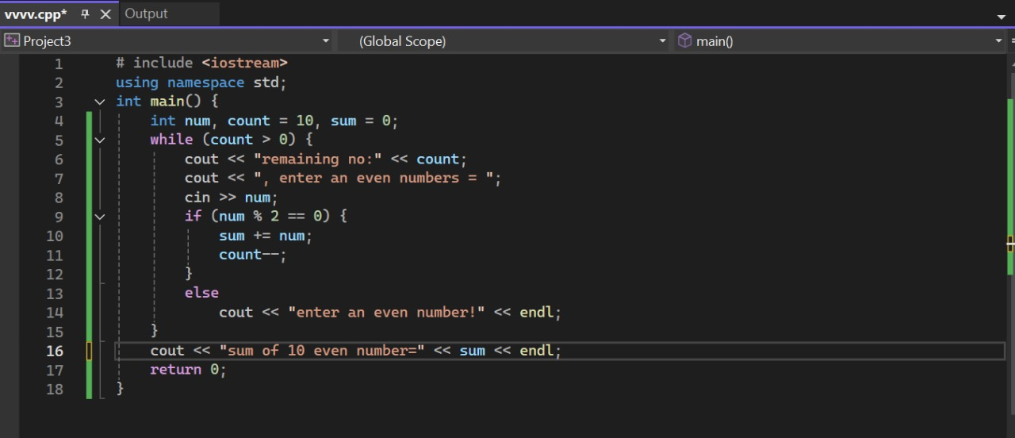

Output:

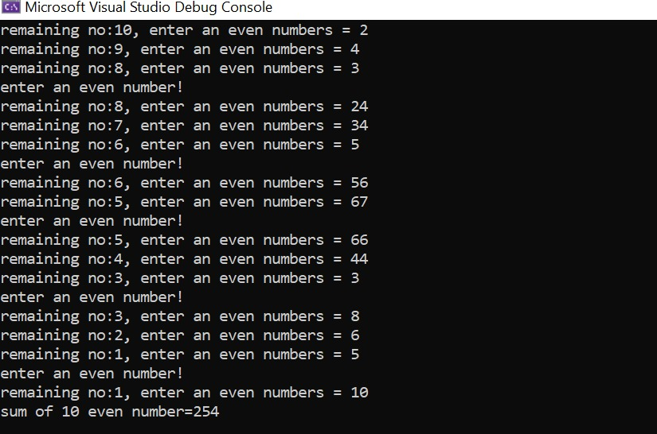

**Task B:**

Write a program that takes a single-digit odd number from the user and generates the pattern shown below.

|  |  |
| --- | --- |
|  |  |

input:

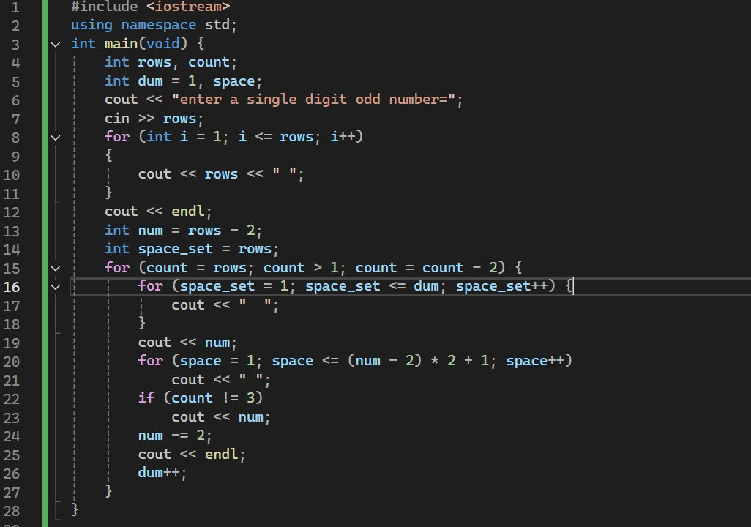

Output:

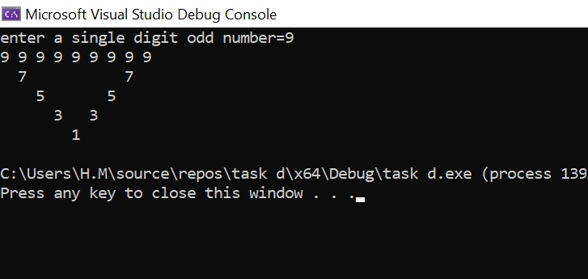

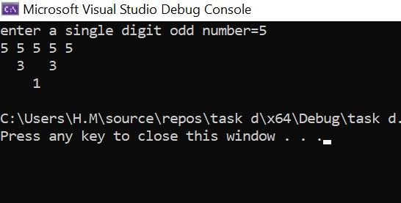

**Task C:**

Write a function **points_distance()** that calculates and returns the distance between two points (X1, Y1) and (X2, Y2). All numbers and return values should be of floating type. Use this function in your main program. The values of the points should be received from the user. The formula to calculate the distance between two points is given below. To find the square root and power, you can use sqrt() and pow() functions respectively.

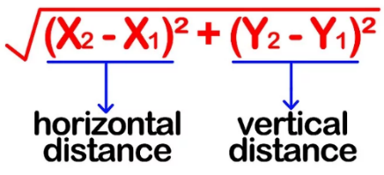

Input:

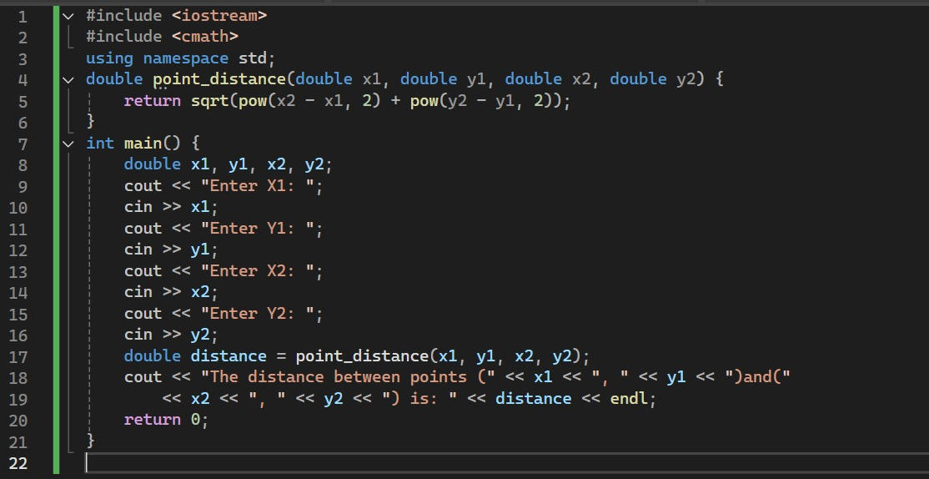

Output:

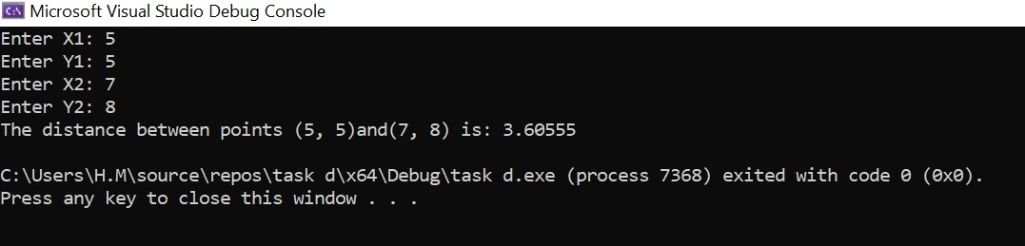

**Task D:**

The harmonic mean is another way of calculating a mean for a set of numbers. The harmonic mean of a set of numbers is given by the equation:

Write a modular program that prompts the user to enter the value of N and calculates the harmonic mean of the set of N numbers (, , *. . .* ,) using the do-while loop. Test your program’s output for the given numbers.

Case 1: N=4 Number = 2, 5, 7, 9 HM= 4.19301

Case 2: N=5 Number = 10, 20, 5, 15, 10 HM= 9.67742

Input:

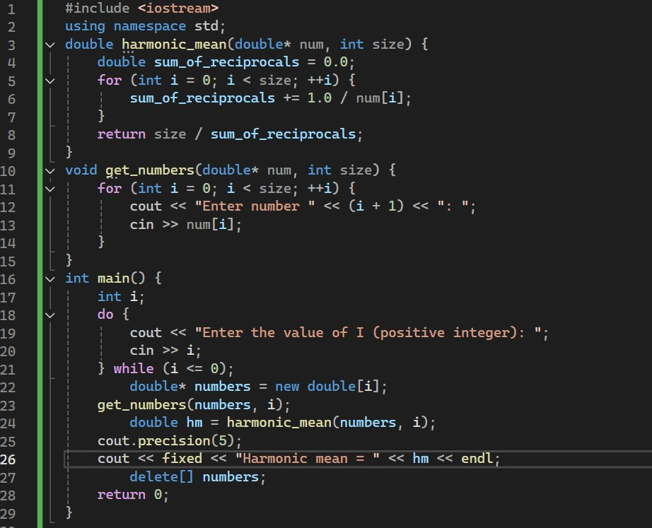

Output:

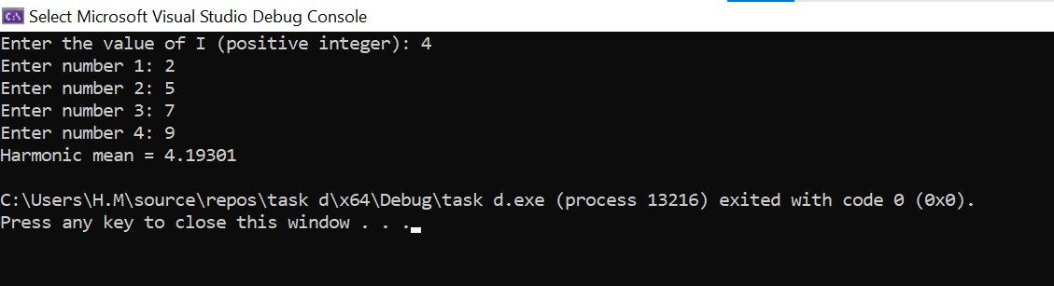

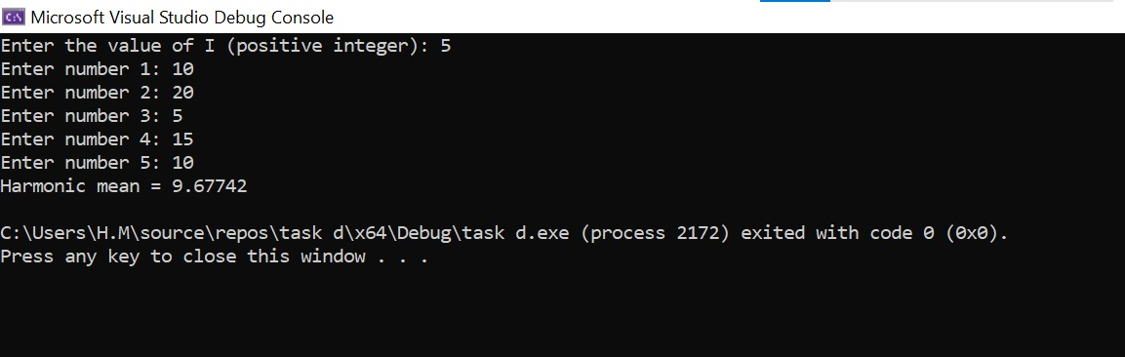

**Task E:**

Write a program that shows the user the following options:

1. Miles to Km
2. Celsius to Fahrenheit
3. Feet to meters
4. Yards to meters
5. Exit program

Each conversion option should be implemented in a separate function. Your main program must keep on prompting the user to select the conversion function of their choice until the user enters a sentinel value (e) to exit the program. Each function gets an input from the user, performs the conversion, and displays the results to the user. After that show the above menu again to allow the user to perform another conversion or exit the program.

input:

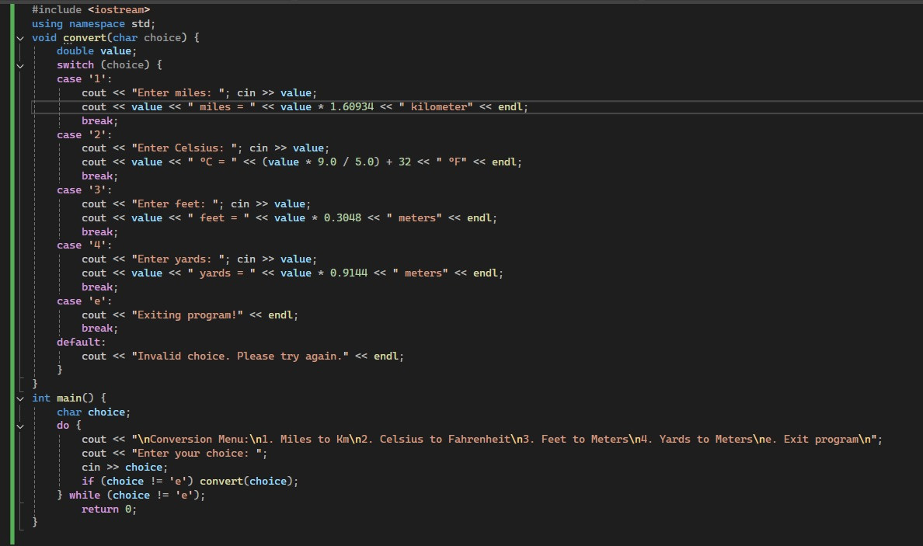

Output:

